Swarthmore’s goals for student learning

Defining Excellence

Swarthmore's commitment, first and foremost, is to intellectual rigor and creativity.  Toward that end, we foster an appreciation of education as a process as well as a product. The experience we offer our students is intended to nurture the confidence, curiosity and humility to be challenged intellectually, to fulfill personal and professional aspirations, and to interact respectfully with those from a variety of backgrounds. We hold to the conviction that the best learning includes both synthesizing existing knowledge and producing new knowledge.  We lay the foundation for students to understand the joys, inspirations, boundaries and goals of ethical and humane scholarship, engaging with the past and participating with others in the creation of an inclusive future.

Tractenberg (2019)

There is no set of practice guidelines specifically for data science, and there is no real rationale

for a separate set that does not include ASA and ACM perspectives. We therefore turn to the

guidelines of these organizations for the initiation of your development of stewardly behaviors.

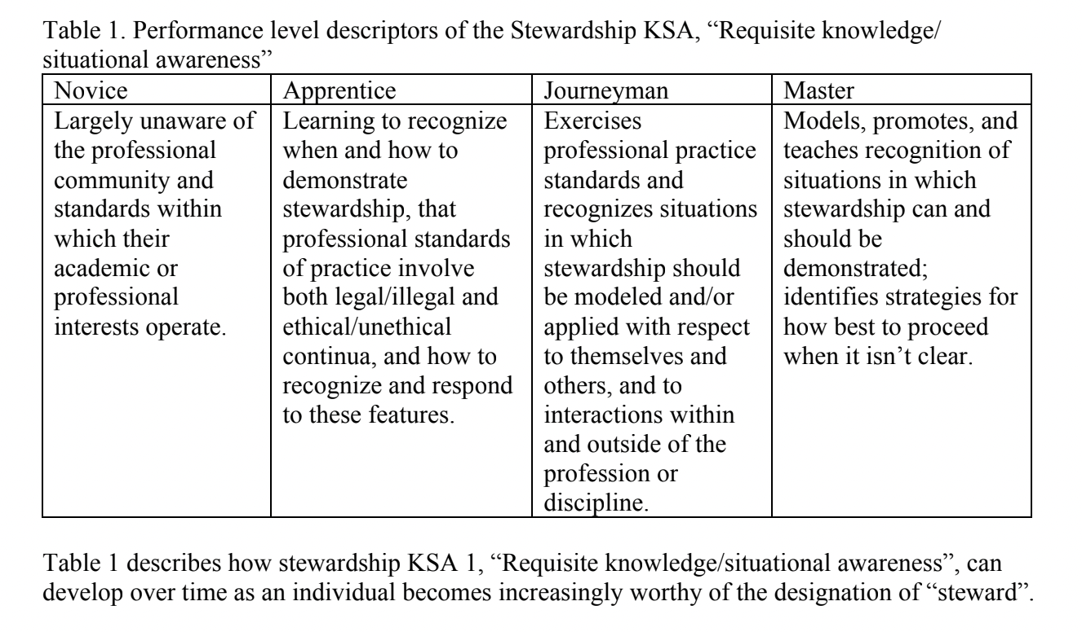

Guidelines are established for “good” or ethical professional practice. Just as there is more to

“learning statistics” than applying “the right” formulae or running software, there is also more to “being a stewardly or ethical statistician/data scientist” than learning [these guidelines].

There are multiple methods for accomplishing many statistics and data science tasks, and the “best” method may depend on what resources are available and the priorities that the data themselves cause/create.

(e.g., hard to collect; hard to verify; prone to measurement error; confounded with other variables in the data set, etc.)

Similarly, there are often multiple ways to identify ethical problems or questions that can arise in practice, before or after they have arisen. There are definitely multiple ways to address ethical problems, including “ignore it”. Factual knowledge is unlikely to help you develop the ability to formulate, and then choose from, multiple possible responses to a breach of ethics - particularly if all of the options are justifiable.

[It is the] second step [of] making decisions that lead to actions that are consistent with [these guidelines] that characterizes the journeyman steward.

…

[A]n important point about the utility and complexity of the ASA and ACM guidelines: they are

not static. [S]uch guidelines require ongoing attention… The steward who “exercises professional practice standards” does so by understanding their dynamic nature, as well as how they interrelate – not by simply memorizing what they contain.

The Ethical Reasoning knowledge, skills, and abilities are actually steps you can walk through:

1. Identification and assessment of one’s prerequisite knowledge;

2. recognition of an ethical issue;

3. identification of relevant decision-making frameworks;

4. identification and evaluation of alternative actions;

Instead of saying to your boss or colleagues, “Hey! You can’t do that!”, you can say, “it looks like we need to X, but according to [guidelines], that could lead to unethical practice or charges that we are unethical.

How can we work around this problem so we can X without doing it unethically?”

What would the ethical practitioner do if they had to also do X?

If there is no way for the ethical practitioner to do X, then that is a 3rd option: do not do X.

5. making & justifying a decision (about the moral issue); and

6. reflection on the decision.